LONGFORD MUNICIPAL DISTRICT

Corporate Affairs,
Aras an Chontae,
LONGFOIRT.

22nd March 2018.

To: Each Member of Longford Municipal District.

Dear Member,

You are requested to attend Meeting of Longford Municipal District to be held in the Council Chamber, Town Hall, Market Square, Longford, on Wednesday,
28th March 2018 at 4.00 p.m. to transact business, as set out on the Agenda hereunder.

Yours sincerely,
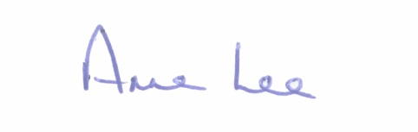

_______________
Anne Lee,
Meetings Administrator.

AGENDA

Prayer before meeting.

1. Confirmation of Minutes of the following meetings of Longford Municipal District–
- Committee Meeting held on the 7th March 2018.
- Monthly Meeting held on the 7th March 2018.

2. Matters arising from Minutes.

3. Management Report - enclosed.

4. Consideration of the Taking in Charge of “Rock View”, Clondra, Co. Longford -
details enclosed.

5. Consideration of applications for funding under the 2018 Community Grant Support Scheme - report enclosed.

6. A.O.B.

